Bohr Model, Quantum Mechanical Model

1. Neils Bohr -connected spectra, and the quantum ideas of Einstein and Planck: the single electron of the hydrogen atom could occupy only certain energy states, stationary states. This explained the line spectra.

2. He explained that each line corresponded to a circular, fixed energy orbit around the nucleus.

3. There were many limitations to this model. Today we know that:

a. electrons exist only is discrete energy levels called shells
b. energy is involved in moving an electron from one level(or shell) to another.
c. The further from the nucleus, the more energy associated with the shell.

4. Heisenberg Uncertainty Principle- It is impossible to know the momentum (mass of electron times velocity) of an electron and its position in space at the same time. One or the other.

5. Quantum Mechanical Model- a mathematical model that incorporates both wave and particle characteristics of electrons in atoms. Arises from work of Schrodinger which describes wave functions and their corresponding energy characteristic and shape. This gives rise to subshells (used to be called orbitals), which are the calculated probability of finding an electron of a given energy in a region of space.

6. Subshell Shapes and Energies
a. Size of subshells
1. subshell of the same shape (s, for instance) grow larger as the distance from the nucleus increases.
b. s subshell
e. f subshell
1. Highly complex shapes.
2. Not involved in bonding in most compounds.
1. Spherical shape
c. p subshell
1. Two lobes each
d. d subshell
1. Four subshells with four lobes each,
centered in the plane indicated in the orbital label.
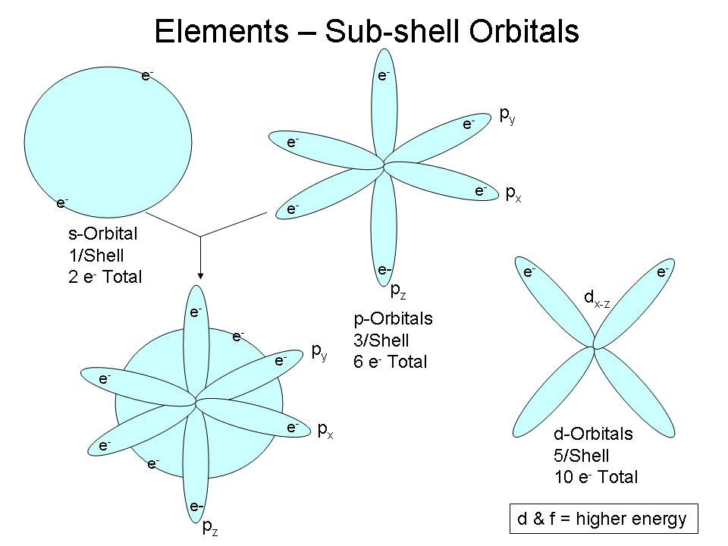
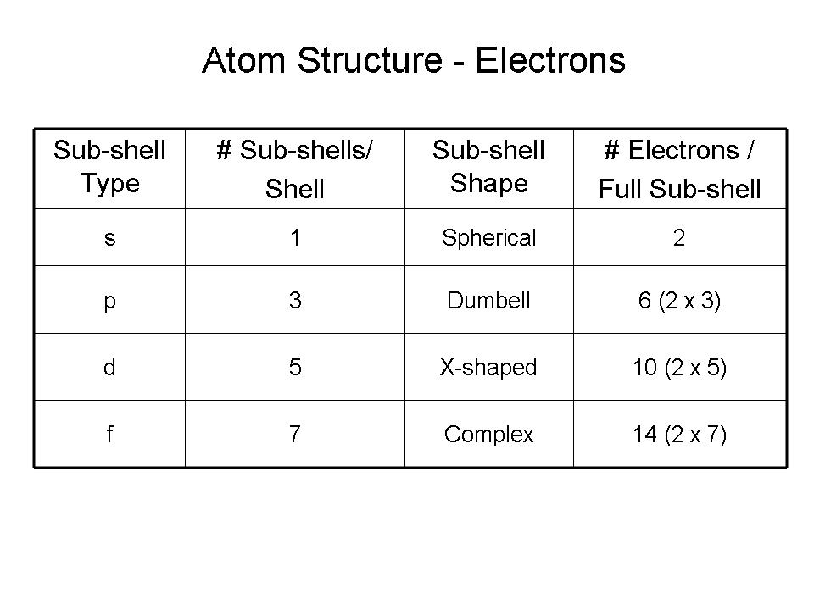

7. Subshell Energies
1. All subshells with the same value of n have the same energy
a. "degenerate orbital" (hydrogen only!)
2. The lowest energy state is called the "ground state"
3. When the atom absorbs energy, electrons may move to higher energy
subshells - "excited state"

8. Electron Configuration- A description of the shells and subshells occupied by electrons.
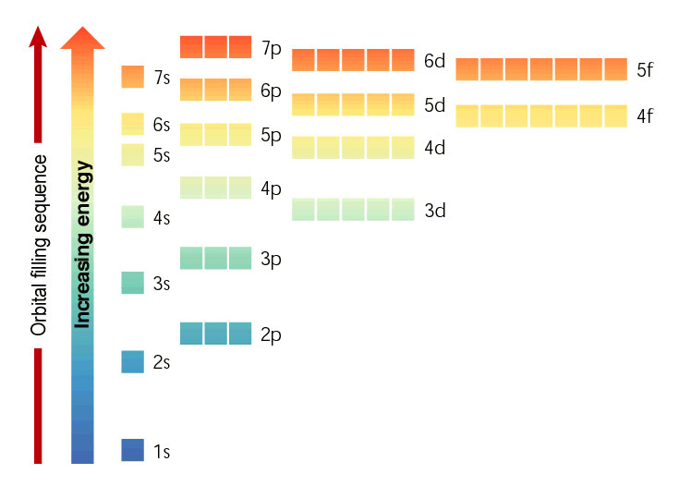
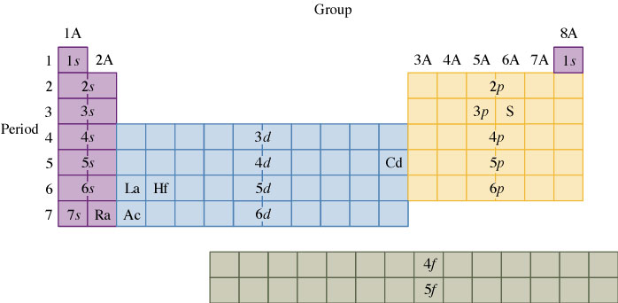

9. Paramagnetic- an atom having one or more un-paired electrons. Will move in a magnetic field.
Dimagnetic- all electrons in an atom are paired. Will not move in an electric field.

10. Nobel Gas configuration- show only electrons occupying the outermost sublevels. Insert [nobel gas element closest with lower atomic number] + outermost sublevels.

Ex. [Ne] 3s¹ ⁻⁻takes the place of 1s²2s²2p⁶

